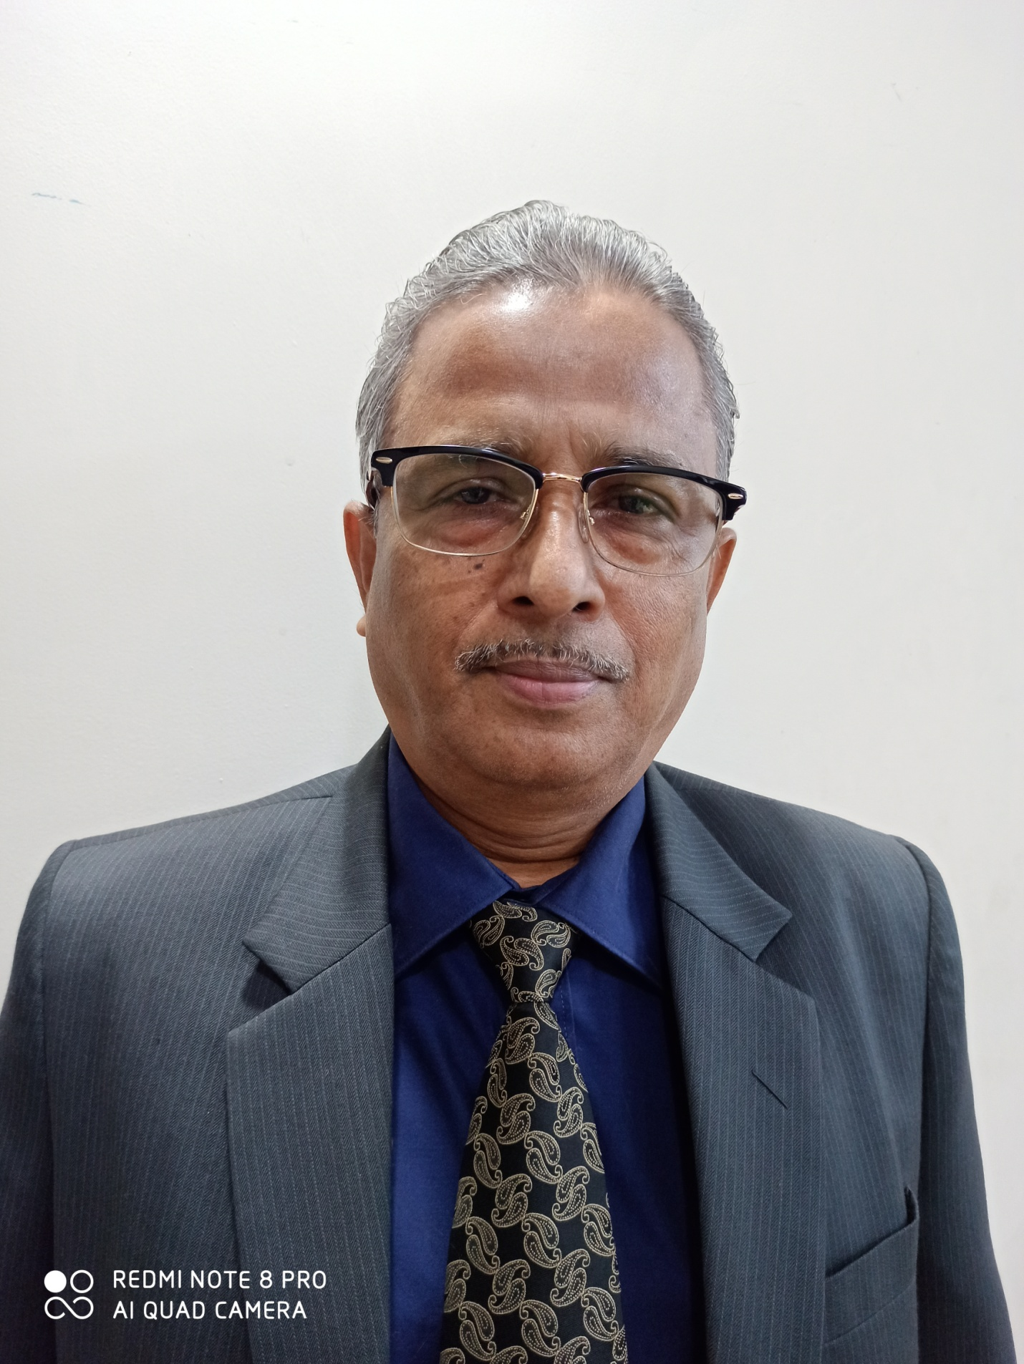
Dr. Bijoy Kumar Bhadra
Designation-ASSOCIATE PROFESSOR
E-mail- bhadra.bijoy3@gmail.com
Administrative /Academic experience
- Having around 33+ Yrs of Experience in banking domain (Foreign Exchange, General Banking and banking Operations.)
- Attended different client faced meetings and took part in Foreign Exchange business programs.
- Having basic knowledge on Computers, Microsoft Excel and Microsoft Word.
- Very good knowledge in conversing with the office clients.
- Experience in Workflow Customization according to business needs.
- Strong analytical, diagnostics and troubleshooting skills and ability to work in a fast- paced and team oriented environment
- Experience in environments requiring direct customer interaction during critical business needs.
- Visiting faculty at Indian Institute of Social Welfare and Business Management (IISWBM),Kolkata and Eastern Institute of Integrated Learning in Management (EIILM),Kolkata (HRM,Law, Math/Statistics, Banking and Research Methodology.)
- Enrolled as an Advocate in High Court, Calcutta

Academic Profile
- Ph.D. in Applied Psychology (HRD) from Calcutta University ,Kolkata in the year 2010
- M.Sc. in Applied Psychology (Gold Medalist) from Calcutta University,1980
- B.Sc. in Physics Honours from Calcutta University in the year 1976

Skill set
- Knowledge on Banking Domain, Foreign Exchange & Merchant Banking and basic Computer skills
Professional Experience
- Indian Statistical Institute, Calcutta-1981-1982-Development of Test Battery/ administration & preparing report for the selection of the personnel for on-the job-training.
- Indian Institute of Planning & Management, New Delhi.-1982-1983-Research/teaching experience with special reference to dynamics or organizational behavior.
- New Bank of India-1983-1993-All Bank jobs including personnel, loans, etc.
- Punjab National Bank- 1993-2016- All jobs specially Foreign Exchange, Merchant Banking.

Research Experience

- Ph.D. work on Management Psychology-Perceived Quality work life in work place of managers in public and private organization sectors- Dept. of Applied Psychology,
Calcutta University.2005-2010
- Managerial success and managerial values of bank managers in public and private sector banks. Specialization in Organization Development & Organizational Behavior.

Certifications
- Certified in Programming Language & Methods, RCC, JU
- Certified in CAIIB, Indian Institute of Bankers, Bombay

Paper Publication/Presentation
- Paper entitled “Managerial values and Managerial Success of some managers in Public/ Private sector Banks”.
- Paper on “How to be a Successful Bank Manager”
- Presented a paper entitled “Organizational Climate and Organizational Commitment of Middle Managers in some Public and Private Sector Organizations.” in the National Seminar in Applied Psychology Dept., -University of Calcutta in 1996.
- Research work on Management Psychology (HRD) and Applied Psychology problem for Ph.D. on QUALITY OF WORK LIFE OF MANAGERS INPUBLIC AND PRIVATE SECTOR ORGANISATIONS.

STRENGTH/AREA OF COMPETENCE
Possesses Theoretical Knowledge & practical experience in HRD program with special reference to:
- Assessment of Psycho-diagnostic potentials of the individuals of the individuals essential for on-the job training for Quality Management.
- Stress management of the executives.

